**QUESTION#1**

Write code of to implement Artificial Neural Network in Python for representing AND function as mentioned in the manual. Understand the code .Please also refer the details from website reference mentioned at the end of the manual?

**CODE:-**

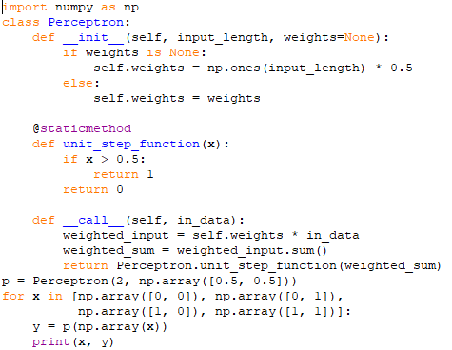

**OUTPUT:-**

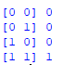

**QUESTION#2**

Write a program to implement neural network in Python to represent OR function?

**CODE:-**

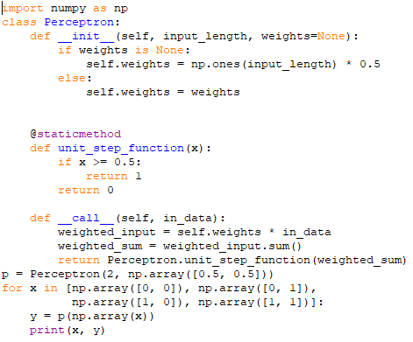

**OUTPUT:-**

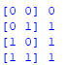

**QUESTION#3**

Write a program to implement neural network in Python to represent XOR function?

**CODE:-**

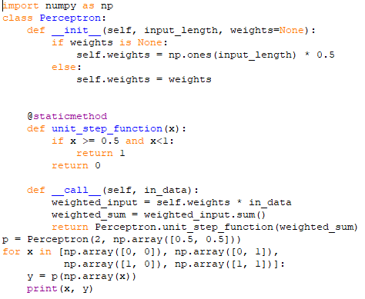

**OUTPUT:-**

